**National University of Computer & Emerging Sciences, Karachi**

**Computer Science Department**



**Spring 2024, Lab Manual – 04**

**Course Code: AI-2002 Course: Artificial Intelligence Lab**

**Instructor(s): Zarnain Maryam Awan**

**Task# 01:**

**Traveling Salesman Problem:**

**TASKS**

Given a set of cities and distances between every pair of cities, the problem is to find the shortest possible route that visits every city exactly once and returns to the starting point. Like any problem, which can be optimized, there must be a cost function. In the context of TSP, total distance traveled must be reduced as much as possible.

Consider the below matrix representing the distances (Cost) between the cities. Find the shortest possible route that visits every city exactly once and returns to the starting point.

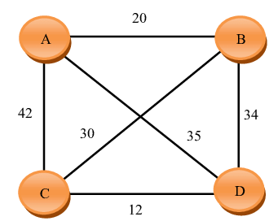

**Task #02:** Implement DFS on graph and tree.

**Task # 03:** Write a program to solve the 8-puzzle problem using the DFS and BFS search algorithm

